
WPFC GU16
ECNL
www.wpfc94black.com
Visit our website for complete
player profiles
Head Coach: Peter Voiles March 25-27, ECNL League Games ~ Danville, CA
Cell: (253)905-1938 Email: pjvoiles@comcast.net March 25, 7:00pm - MSC; Cytomax Fields, Lower
ECNL Staff Coach: Brian vanBlommestein March 26, 9:00am - MTV; Diablo Vista Park
Cell: (253)229-9673 Email: vbrian@wcpsolutions.com March 27, 3:30pm - MTV; Diablo Vista Park
ECNL Staff Coach: Scott Halasz
Cell: (206)713-2444 Email: sahalasz@msn.com
Asst Coach: Pete Shimer Manager: Andi Bohnett
Cell: (206)890-7676 Email: pshimer@deloitte.com Cell: (253)225-2888 Email: dbajbohnett@comcast.net

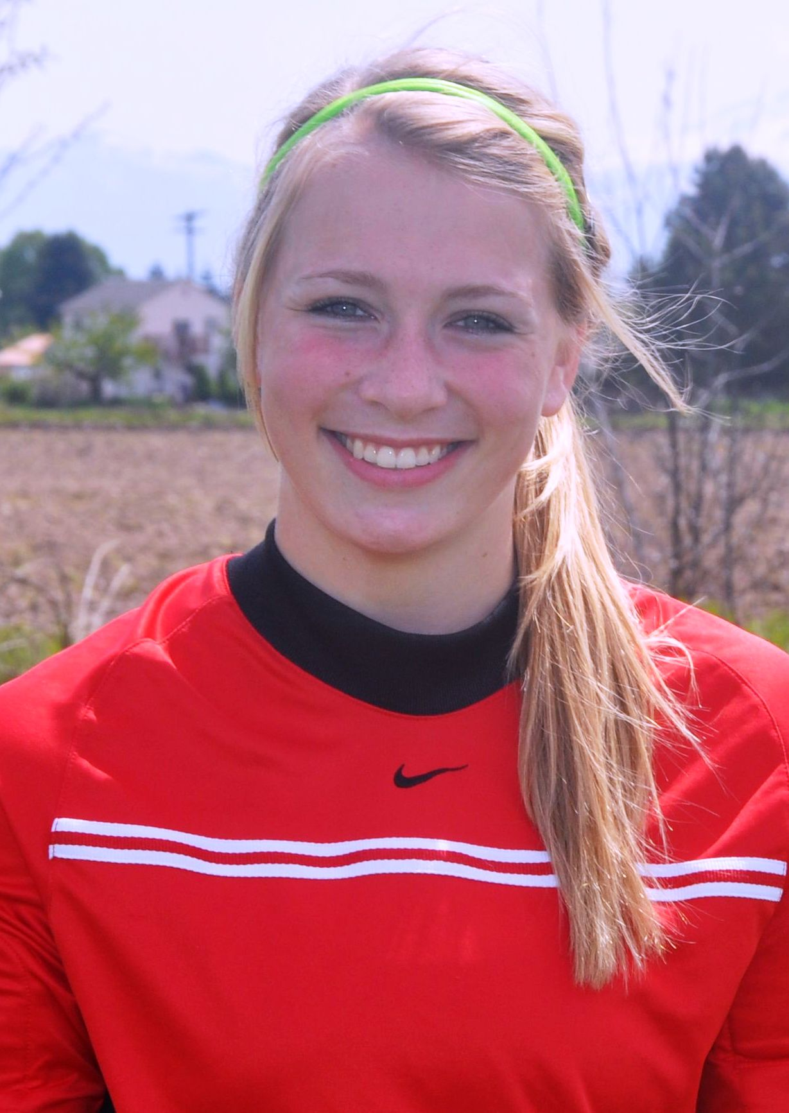  #1 Sarah Shimer 2013  Goalkeeper 5’7 140lbs  NCAA ID: 1103446270  GPA: 3.81 Cambridge Prep Program  Natl: USYS Training Center, 2010  ODP: Regional Camp ’08-2010  Club: 2010 Team Captain, Region IV Semifinalist, WA State Champions, PDL Div1 Champions  Contact: sshimer22@gmail.com | 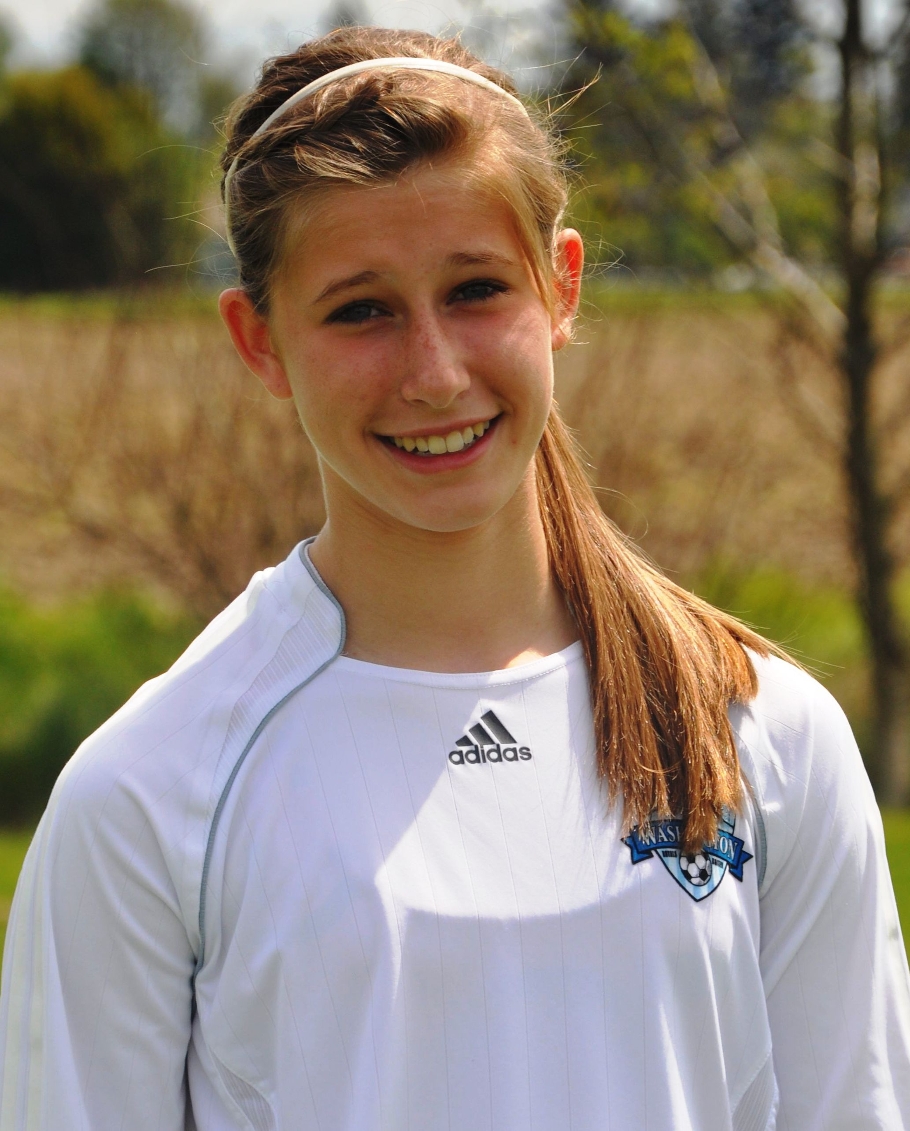  #2 Mariah O’Neil 2013  Mid/Forward 5’7 130lbs  GPA: 4.0 (Honors)  Club: 2010 Region IV Semifinalist, WA State Champion, PDL Div I Champion, Leader in assists with 6 game winning assists, Team Captain, 2009 Denver Cup Finalist  Contact: gin30pat@hotmail.com
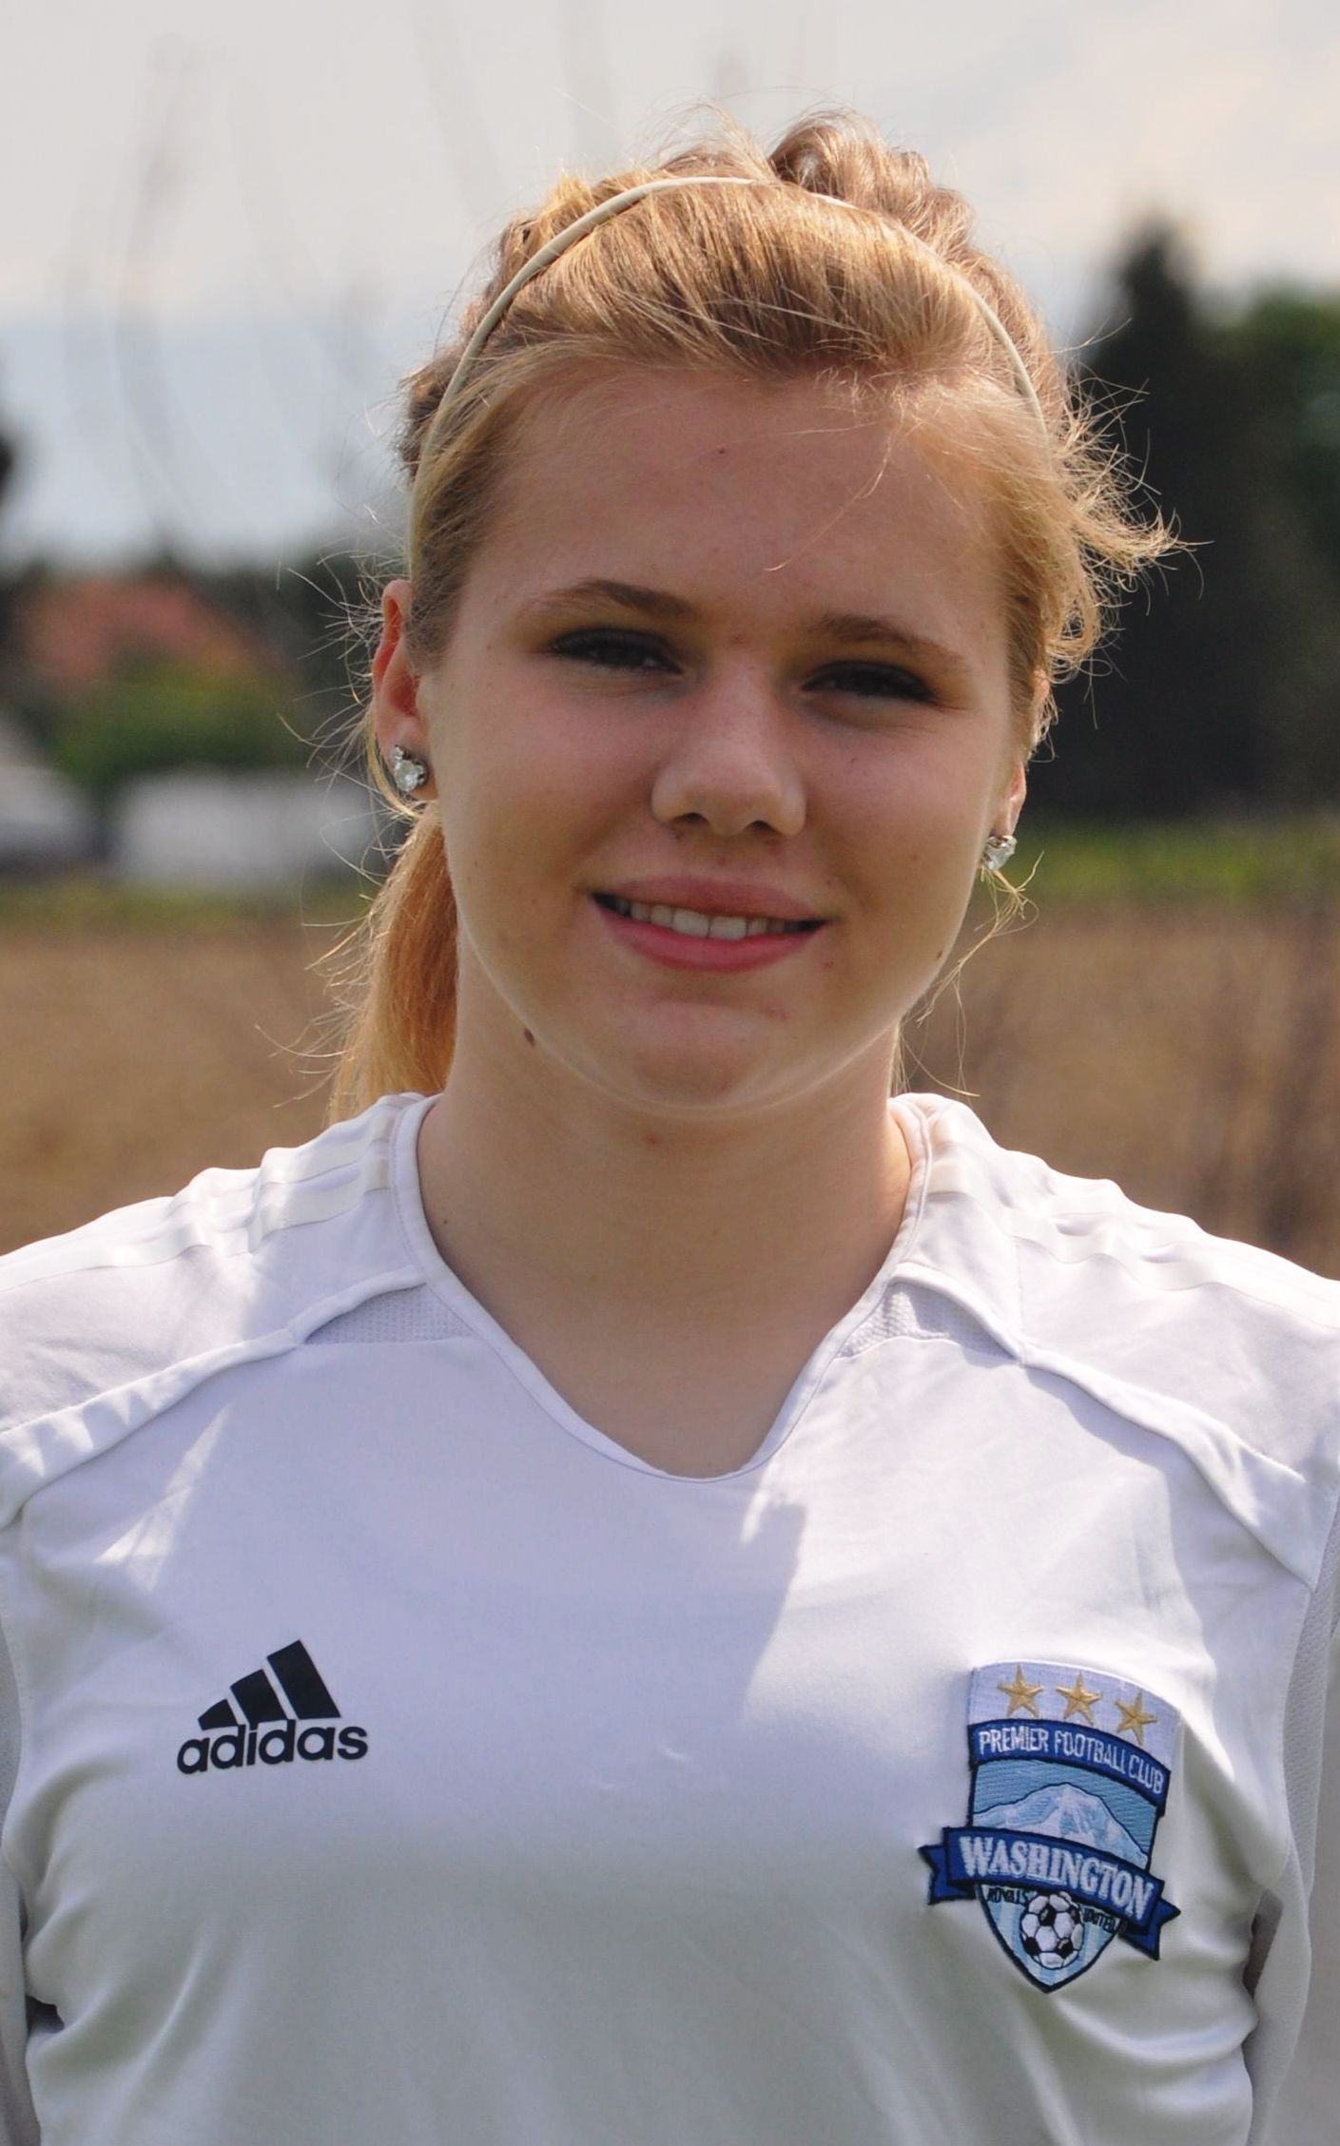  #3 McKenzie Phillips 2013  Mid/Defense 5’7 145lbs  GPA: 3.97 (Honors)  Club: 2010 Region IV Semifinalist, WA State Champion, PDL Div I Champion 2009 WA State Finalist, Denver Cup Finalist, Manchester United Participant  Contact: fishcounter1@comcast.net | 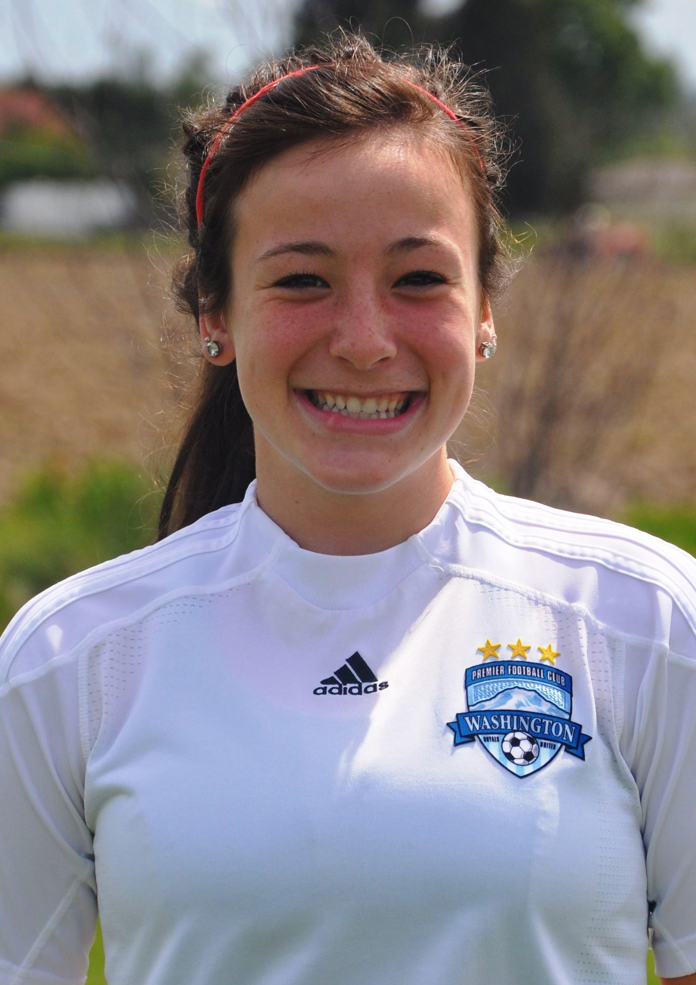  #4 Kelli McCluskey 2013  Left Back 5’4 123lbs  GPA: 3.5  ODP: WA State Team ’08-Present  Regional Camp 2009  Club: Region IV Semifinalist, WA State Champion, PDL Div I Champion  Contact: mike.mccluskey05@gmail.com
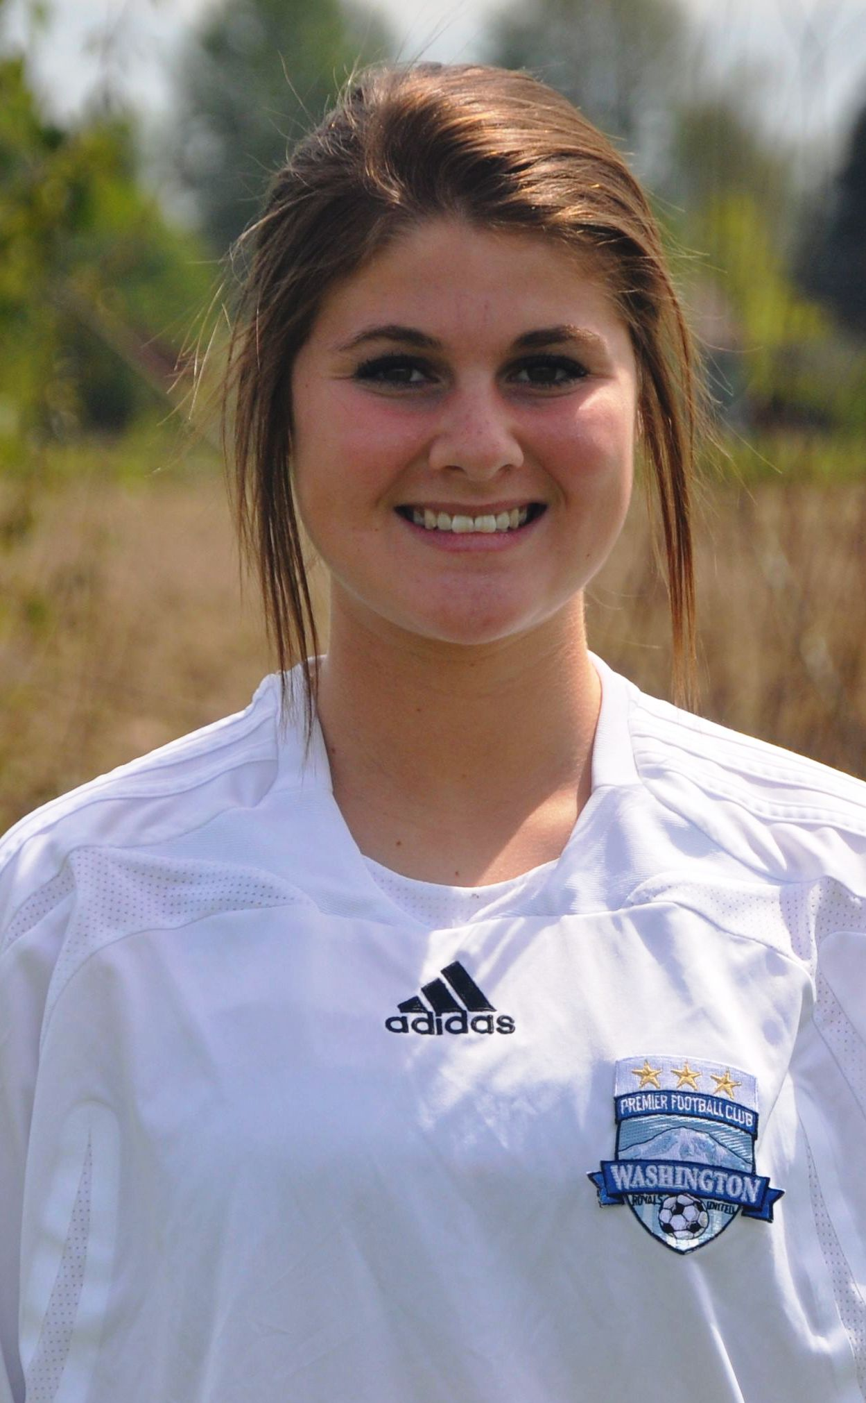  #5 Abbey Bergquist 2013  Mid/Forward 5’7 135lbs  GPA: 3.7  Natl: USYS Training Center, Present  ODP: WA State Team ’08-Present  Regional Camp ’08-Present  Regional Team ’10-Present  Club: 2010 Team Captain, Region IV Semifinalist, WA State Champ  Contact: bsbergquist@comcast.net | 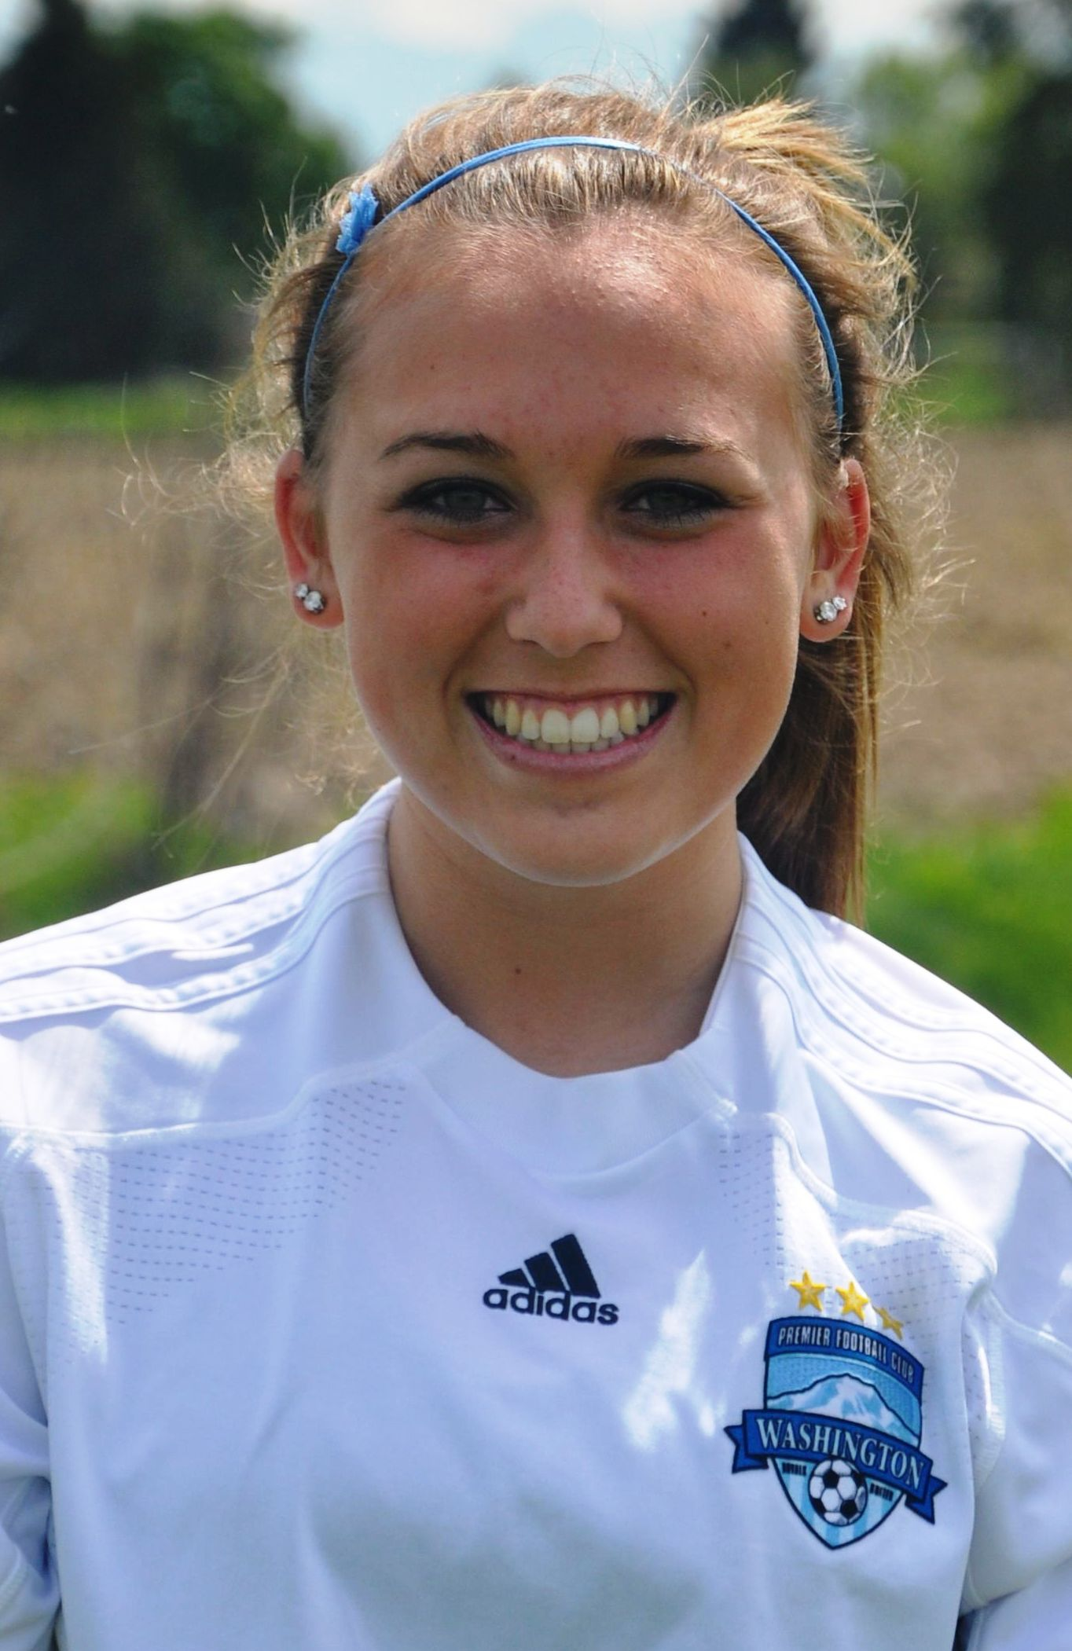  #6 Paige Serwold 2013  Mid/Forward 5’6 130lbs  GPA: 3.7  ODP: WA State Pool ’08-Present  WA State Team ’10-Present  Club: 2009 US Club Soccer Nationals Finalist  High School: Varsity Freshman Year, Honor Society Officer  Contact: paigevalley@yahoo.com
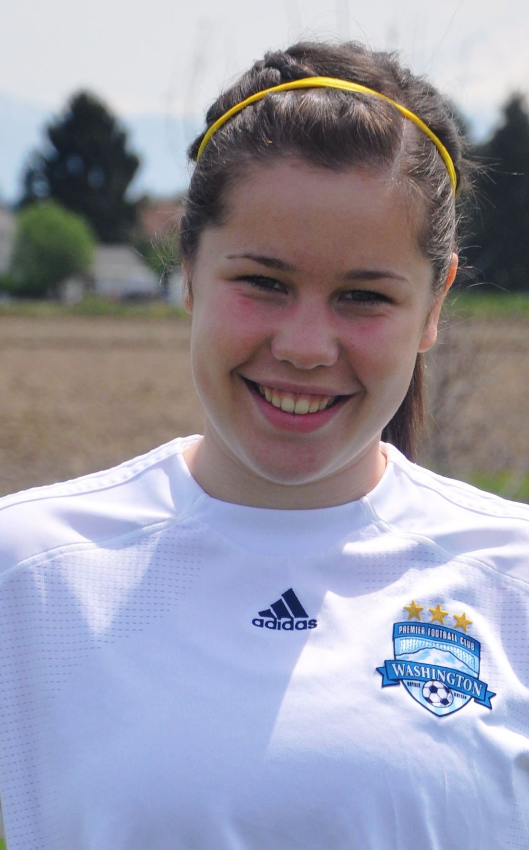  #7 Lauren Larson 2012  Forward 5’7 140lbs  GPA: 3.6  Club: 2010 WA State Cup Semifinalist 2009 WA State Cup Quarterfinalist, Rainier Challenge Finalist, Nike Crossfire Challenge Semifinalist, Pleasanton Rage 1st Place  Contact: lauren.larson7@yahoo.com | 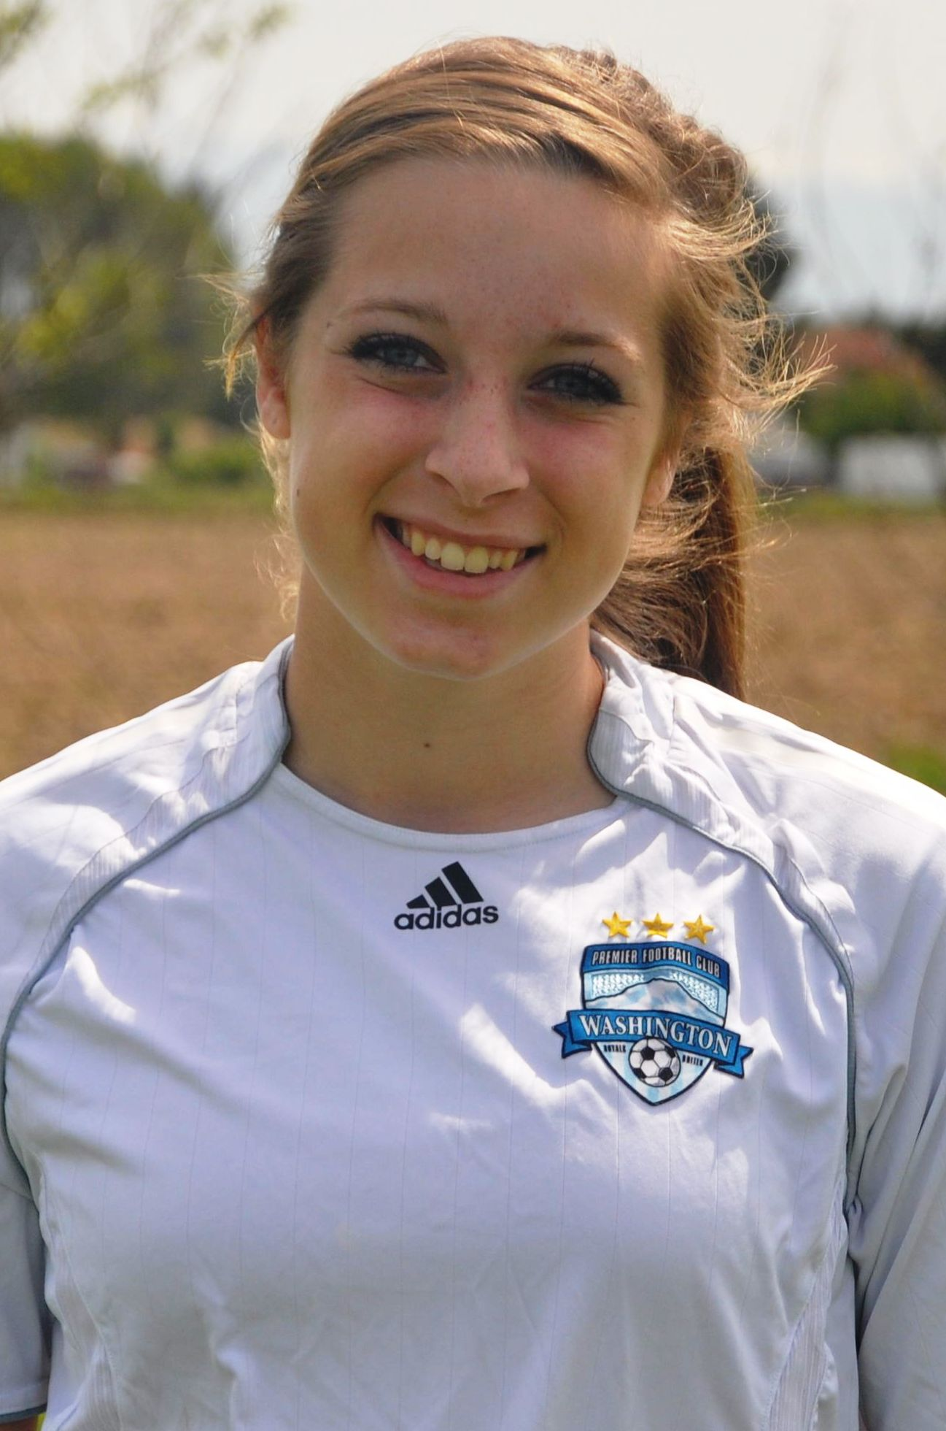  #8 Jeanette Webster 2013  Forward/Mid 5’7 131lbs  GPA: 3.7  Club: 2010 Region IV Semifinalist, WA State Cup Champion, PDL Div I Champion 2009 Manchester United Participant, Nomads Thanksgiving Finalist, Denver Cup Finalist, Beaverton Cup Champion  Contact: webster5628@comcast.net

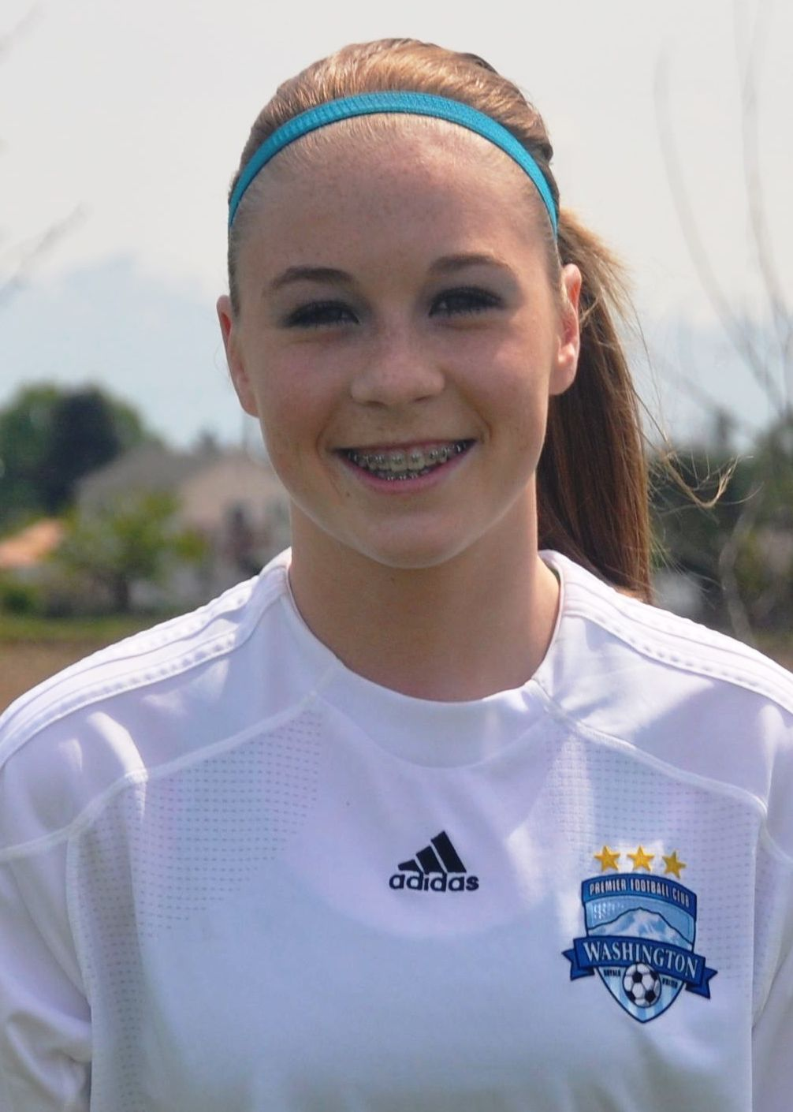  #9 Emily Meeks 2013  For/Def/Mid 5’8 135lbs  GPA: 2.5  Club: 2010 WA State Cup Semifinalist 2009 WA State Cup Quarterfinalist, Rainier Challenge Finalist, Nike Crossfire Challenge Semifinalist, Pleasanton Rage Showcase 1st Place  Contact: michael-cindy@comcast.net | 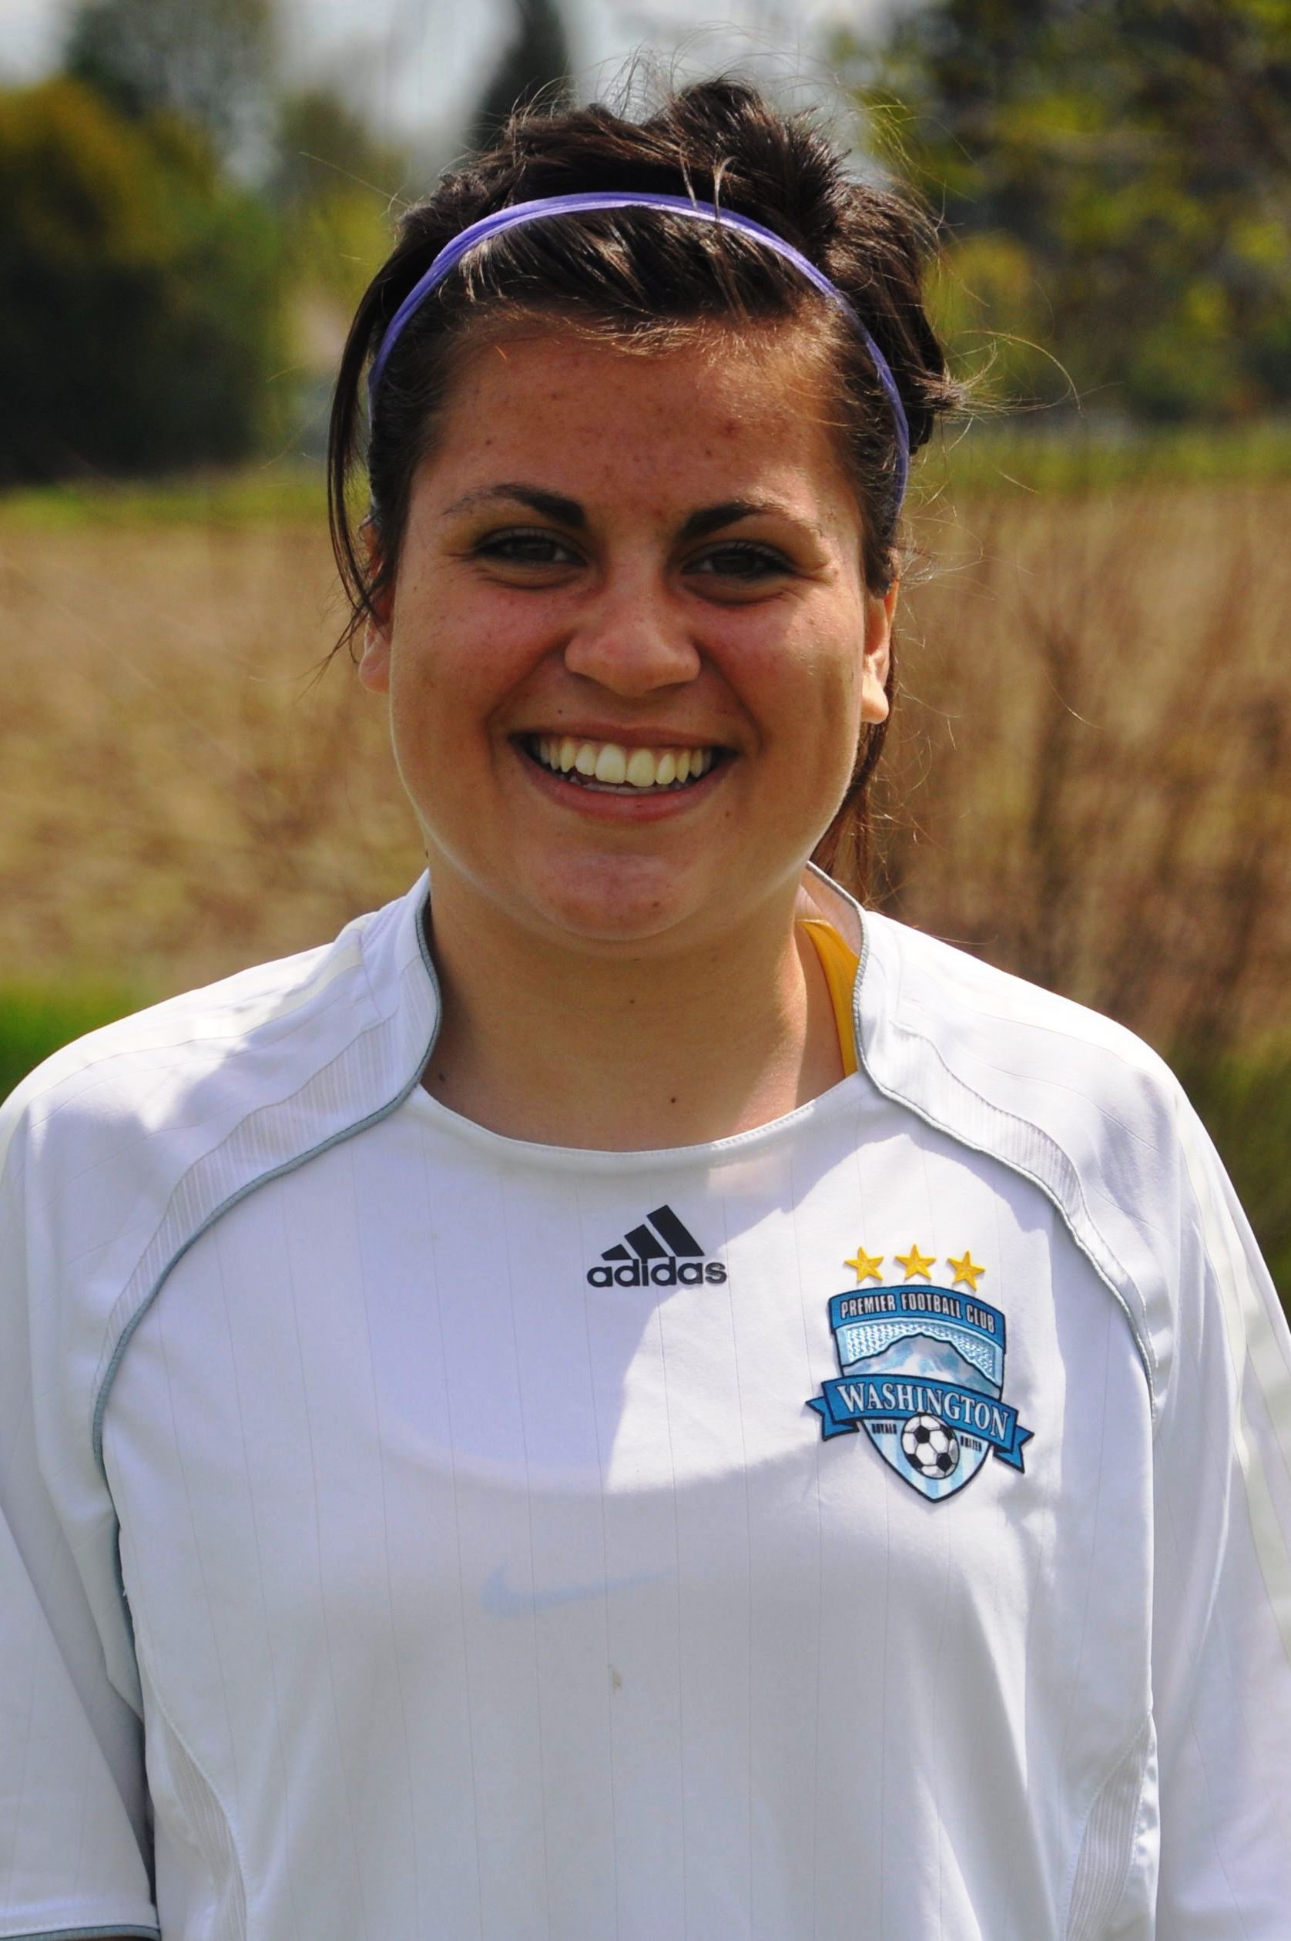  #10 Helena Moreno 2013  Right Back 5’4 125lbs  GPA: 3.3  Club: 2010 Region IV Semifinalist, WA State Champion, PDL Div I Champion 2009 WA State Cup Finalist, Manchester United Participant, Nomads Thanksgiving Finalist, Denver Cup Finalist  Contact: mary.j.moreno@comcast.net
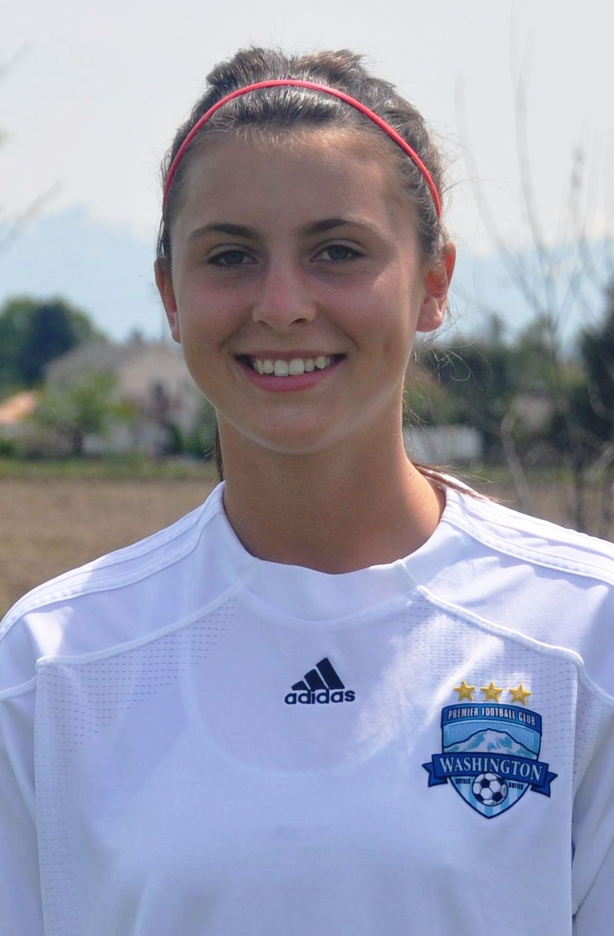  #11 Kaylie Rozell-Pidge 2013  For/Def/Mid 5’9 135lbs  GPA: 3.5  ODP: WA State Team ’10-Present  NM State Team ‘07-‘10  Regional Camp ‘08-‘09  High School: 2010 League MVP, League Champions, 1st Team All State 2009 Mayfield HS Varsity, “Best Utility Player” Award  Contact: kaylierozell@yahoo.com | 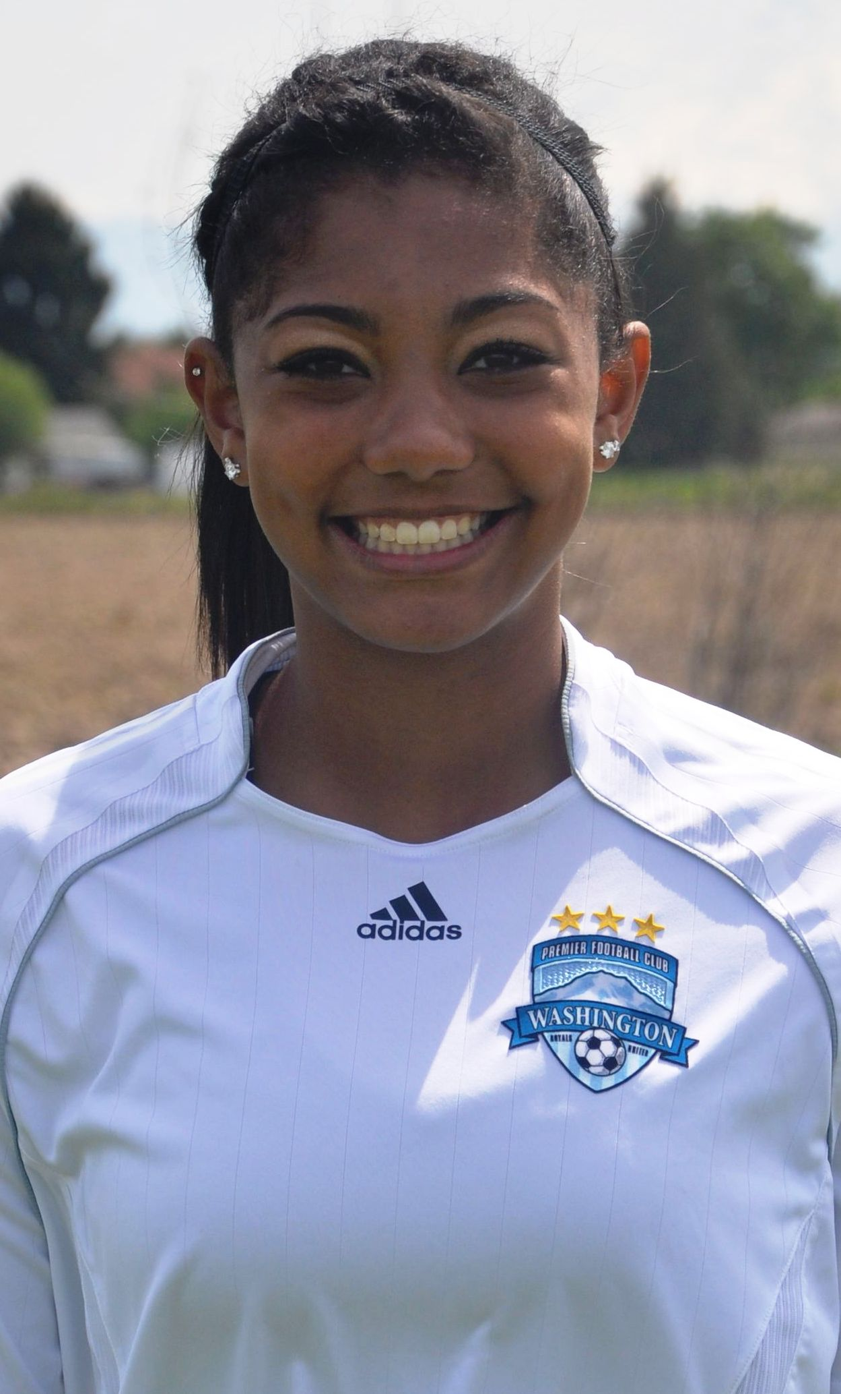  #12 Shyann Glasser 2013  Mid/Def/For 5’8 139lbs  GPA: 3.0  Natl: USYS Training Center, 2010  ODP: WA State Team ’08-Present  Regional Camp ’08-Present  Regional Team ’09-‘10  National Pool ’09-‘10  Club: 2010 Region IV Semifinalist, WA State Cham, PDL Div Champ  Contact: genawallaceshyann@yahoo.com
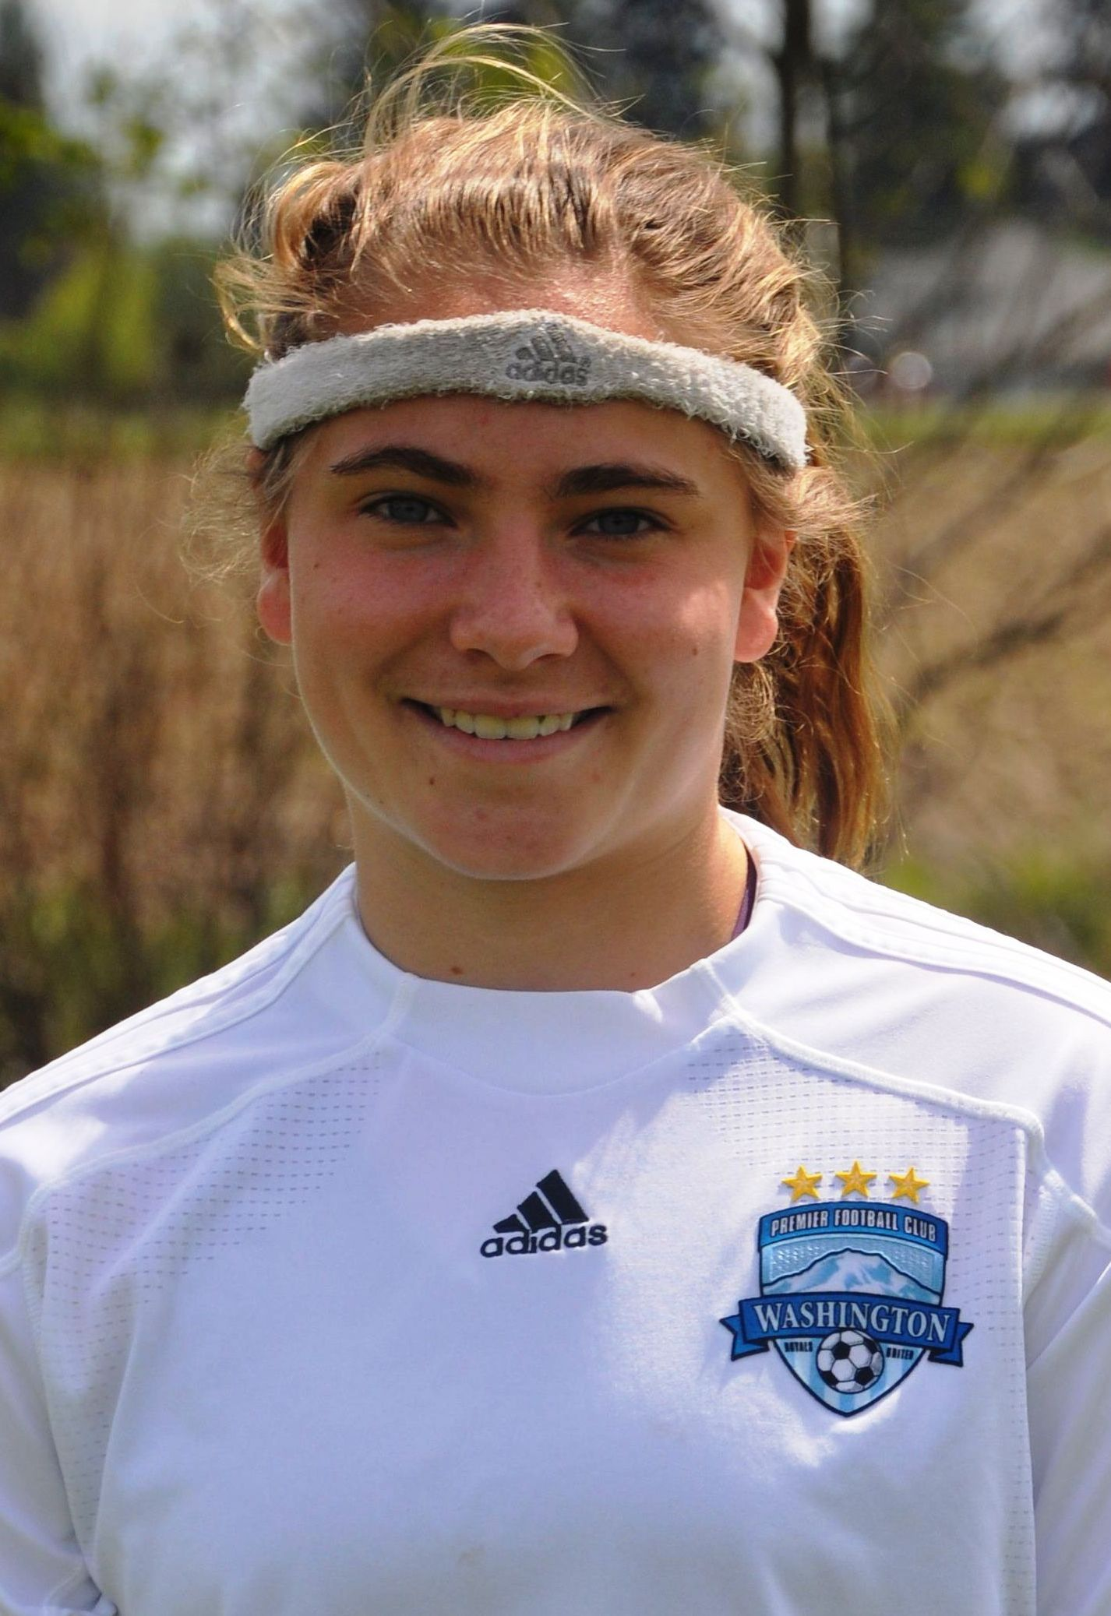  #13 Mackenzie Dowd 2013  Centerback 5’5 138lbs  NCAA ID: 1010310040  GPA: 3.99 Honors/AP PSAT: 197  Natl: USYS Training Center, 2010  ODP: WA State Team, Regional Camp 2008-10, Reg IV Finalist ‘09  Club: 2010 Team Captain, USYS Region IV Semifinalist, WA State Cup Champ, PDL Div I Champ  Contact: dowdhouse@comcast.net | 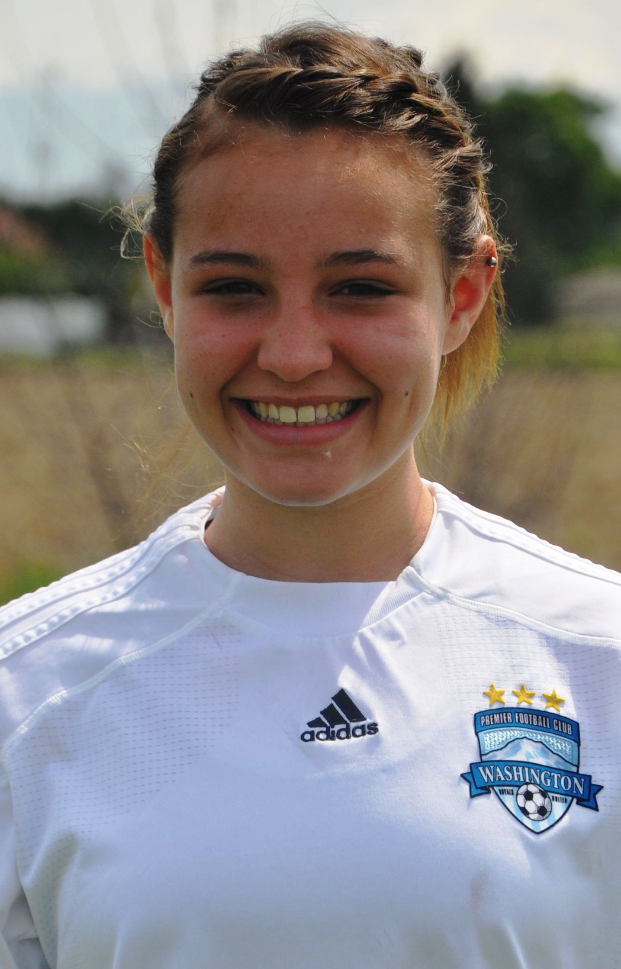  #14 Miranda Caballero 2013  Center Mid 5’7 142lbs  GPA: 3.95  Natl: USYS Training Center, 2010  ODP: WA State Team 2008-10  Regional Camp 2010  ODP Region IV Semifinalist  Club: 2010 WA State Cup Semifinalist 2009 WA State Cup Quarterfinalist  Contact: shugdinis@wavecable.com
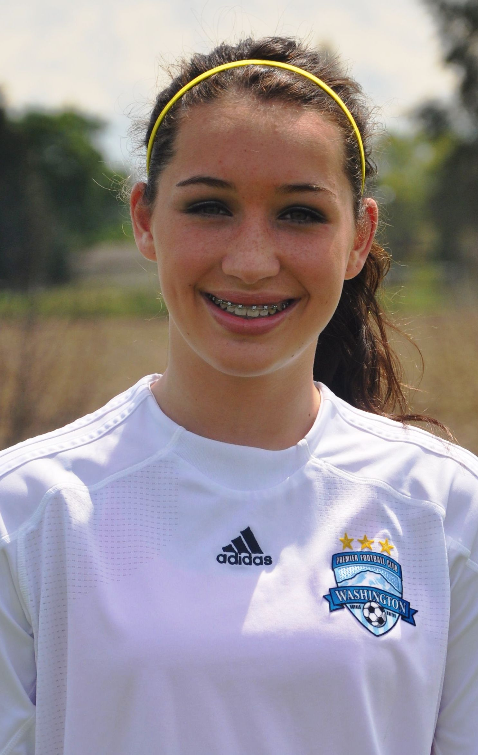  #15 Sarah Carter 2013  Centerback 5’9 135lbs  GPA: 3.95  Natl: USYS Training Center, 2010  ODP: WA State Team ’07-Present  Regional Camp ‘08-Present  ODP Region IV Semifinalist  Club: 2010 Team Captain,  WA State Cup Semifinalist  2009 WA State Cup Quarterfinalist  Contact: dtdscarter@comcast.net | 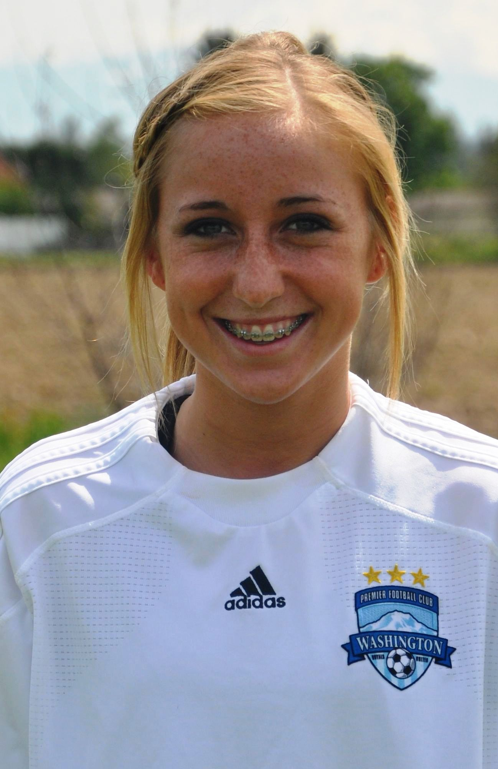  #16 Alexandra Bohnett 2013  Mid/For/Def 5’7 130lbs  GPA: 3.5  ODP: WA State Pool ’08-’09  Club: 2010 WA State Cup Semifinalist, Rainier Challenge, Nike Cup (Lake Oswego) and Crossfire Challenge Champions  High School: 2010 Narrows League 4A-All League, 2nd Team  Contact: dbajbohnett@comcast.net
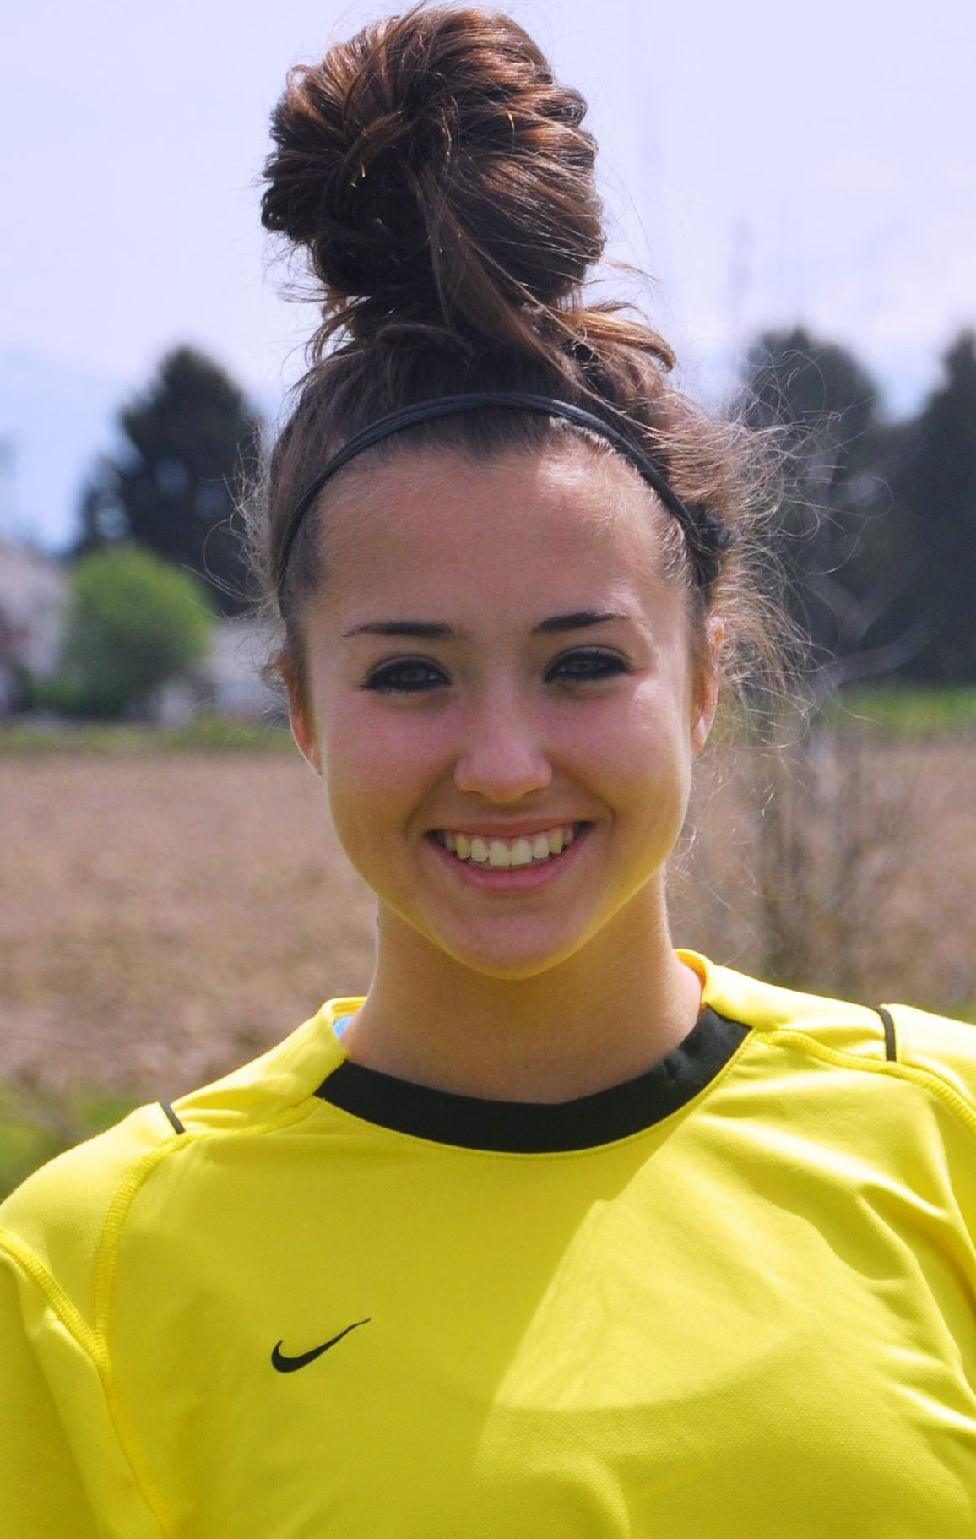  #18 Emma Makela 2013  Goalkeeper 5’9 145lbs  GPA: 3.3  Natl: USYS Training Center  Goalkeeper ’10-Present  ODP: WA State Team ’08-Present  Regional Camp ’08-Present  ODP Region IV Semifinalist  Virginia State Team ‘08  Club: 2009 WA State Cup Semifinalist  Contact: kmakela@aol.com | 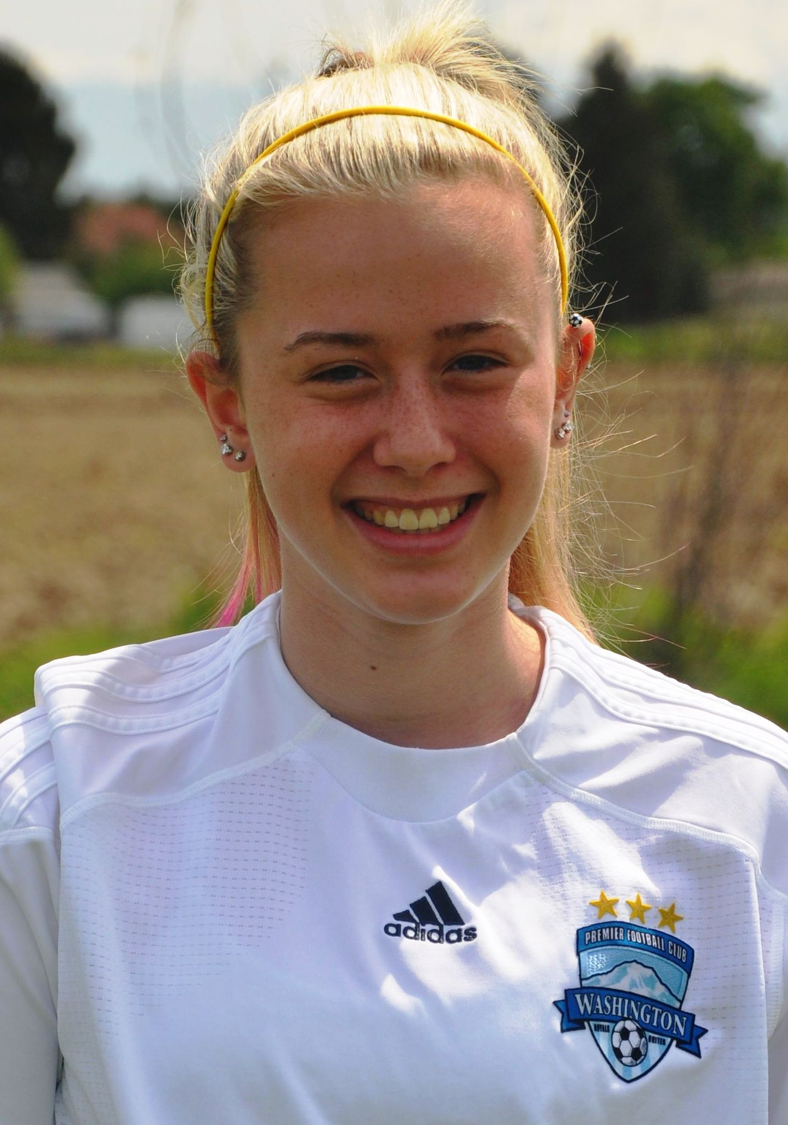  #19 Melanie Vinson 2013  Mid/Forward 5’7 130lbs  GPA: 3.7  Club: 2010 WA State Cup Semifinalist 2009 WA State Cup Quarterfinalist, Rainier Challenge Finalist, Nike Crossfire Challenge Semifinalist, Pleasanton Rage Showcase 1st Place, 2008 US Club Washington Cup Champion  Contact: vinsonm5@msn.com
2010 Tournament Champions
Nike Crossfire Challenge ~ Lake Oswego Nike Cup ~ WPFC Rainier Challenge

